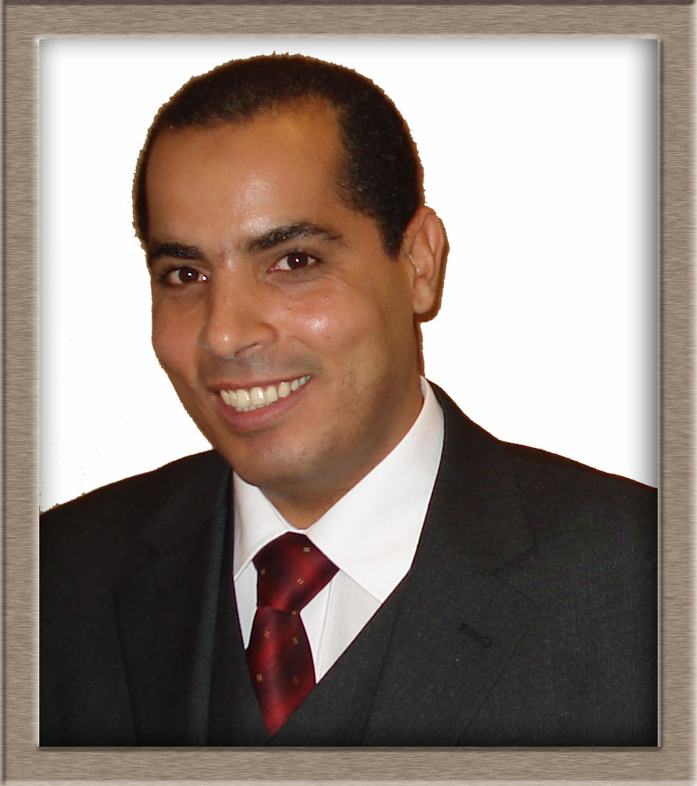
CURRICULUM VITAE
1- Personal Details

Name : Omar Abdel Gaber Mohamed Aly
Date of Birth : 24.09.1970
Address : Electrical Engineering Department, Faculty of Engineering
Assuit University, Assuit-Egypt.
Nationality : Egyption
Telephone : 0020882373617
Mobile : 00201002300244
Email : omar.aly@aun.edu.eg, o.aly@mu.edu.sa, oagazaz_70@yahoo.com
Major Area : Communication and Digital Signal processing.
Fields of Interest: Wireless Communication, Cognitive radio, Ultrasonic Indoor Positioning System, Ultrasonic and Microwave Imaging and Automotive Radar.

2- Education & Qualifications

2001-2006: Ph.D. in Communications, Department of Microwave and Communication
Engineering FEIT-IESK, OTTO-VON-GUERICKE University Magdeburg,
Magdeburg - Germany.
Title of the Dissertation: Enhancing The Performance of Spread Spectrum
Technique in Different Applications.

1996 – 1998 : M.Sc in “Communication Engineering” Awarded in 1998, from
Electrical Eng. Dept., Assuit University, Egypt
The thesis entitled “ Voiced / Unvoiced / Silence Classification of
Speech Using Fuzzy Neural network”.
The M.Sc. Courses are:
1 – Speech Signal Processing.
2 – Digital Signal Processing Card.
3 – Numerical Analysis and Programming Methods.
4 – Digital Signal Processing.
5 – Electronics Circuits.

1988 – 1993 : B. Sc. In “ Communication and Electronics Engineering” with a
degree “ Very Good “, from Faculity of Eng., Electrical Eng. Dept.,
Assuit University, Egypt
1986 – 1988 : Secondary School
3- Professional Activities:

2014 Till 2015 | Head of the lab development committee in Electrical Engineering Department college of engineering Majmaa University, Majmaa - KSA.
2013 Till 2015 | Executive Supervisor for the communication and electronics bridging program. college of engineering Majmaa University, Majmaa - KSA.
2013 Till 2015 | The head Of Academic Advising Unit. college of engineering Majmaa University, Majmaa - KSA.
2013 Till 2014 | Member of the development of the academic plane of the Mechatronics Program - college of engineering Majmaa University, Majmaa - KSA.
2011 till 2013 | The head of Electrical Engineering Department in the college of engineering Majmaa University, Majmaa - KSA.
2010 till 2012 | The head of the electronic services unit in the college of engineering Majmaa University, Majmaa - KSA.
2010 – 2011 | Member of the development of the academic plane of the college of engineering Majmaa University, Majmaa - KSA.
10-2009: 5-2010 | The head of the quality assurance unit in the college of engineering Majmaa University, Majmaa - KSA.
2009 Till 2015 | Assistant Professor: Electrical Engineering Department- college of engineering, Majmaa University, Majmaa - KSA.
2009 | Organizer of the electrical engineering department in the development project of the college of engineering Assiut University
2007 – 10-2009 | Assistant Professor: Electrical Engineering Department- Faculty of engineering, Assuit University, Assuit-Egypt.
2001 – 2006 : | Research Assistant: Department of Microwave and Communication Engineering FEIT-IESK, OVG university Magdeburg , Germany.
1998 – 2001 : | Teaching Assistant: Electrical Engineering Department, Assuit University, Assuit-Egypt.
1995 –1998 : | Demonstrator (teaching and research assistant), in Electrical Engineering Department, Assuit University, Assuit-Egypt.

4. Teaching Experiences:
A. Undergraduate Courses Taught

1. Analog Communication Systems.
2. PLC.
3. Electronics I
4. Electronics II.
5. Digital Signal Processing.
6. Digital Communication Systems.
7. Computer Languages (Basic, Fortran, C++ and MatLab)
8. Electric Circuits.
9. Physics I
10. Physics II
11. Electric Circuit

B. Graduate Courses Taught

1. Advanced Topics in Wireless Communications.
2. Digital and Analog Communication Systems.
3. Electronic Measurements.
C. Projects Supervision for Final Year B.Sc. Students

- Smart Mobile Care Security System.
- Ultrasonic Indoor Positioning system IUPS.
- Design and implementation of CDMA Transmitter/Receiver system.
- Hardware implementation of spread spectrum signal correlator.
- Hardware implementation of PN-code generator using PIC.
- Software implementation of PN-code Generator.
- Graphical User Interface (GUI) for in door positioning system.
- Software and hardware implementation of a MODEM.
D. Computer Experience and Software Knowledge

- Experienced with, Fortran and C++ Computer Languages.
- Experienced with DSP, MATLAB.
- Experienced with Many Graphics and Spread Sheets Software Such As Excel and Power Point.
- Experienced with Many Word Processing Packages such as Microsoft Word and Latex.
- Experienced with Many Internet Utilities and Web Pages Design.
- National Instruments MULTISIM.
- FPGA programming using VHDL language.
- SIMENS PLC Programming.
- SIMENS SCADA Systems.
5- Areas of Specialization

- Communication.
- Digital Signal Processing.
- Multi-Resolution Time-Frequency Analysis and Wavelet Transforms.
- Higher Order Statistics.
- Super Resolution Techniques.
- Speech Analysis and Synthesis.
- CDMA Mobile Communication.
- Ultrasonic Imaging.
- Microwave Imaging.
- Indoor Positioning System.
- Automotive Anti-Collation Radar.
6- Languages

- Arabic (mother tongue).
- English - Very Good written and spoken, TOEFL Score 520.
- German – Very Good spoken and Good written.
7- Funded Projects:
[1] Omar. A. M. Aly and Abdel-Rahman Al-Qawasmi, "Development of Spectrum Sensing Technique for future Cognitive Radio Applications Based On Wavelet Transform and Higher Order Statistics" funded from the Engineering and Applied Sciences Research Center, majmaah university for one year from 3-2012 to 3-2013.
8- Publications
- Omar A. M. Aly, " Two-Stage Spectrum Sensing Algorithm for Low Power Signals in Cognitive Radio", The Second Saudi International Electronics, Communications and Photonics Conference , Riyadh 30 - 27 April, 2013 SIECPC '13.
- Omar A. M. Aly, Abdel-Rahman Al-Qawasmi and Ahmed G. Abo-khalil, " Noise Immune Spectrum Sensing Algorithm for Cognitive Radio", IEEE 30th NATIONAL RADIO SCIENCE CONFERENCE (NRSC 2013), April 16‐18, 2013, Cairo, Egypt 2013.
- Abdel-Rahman Al-Qawasmi and Omar A. M. Aly, " Low-Complexity FEC Encoding Technique Based Parity Selected Codes, " IEEE Signal Processing Symposium SPS-2013, 5-7 June 2013, Jachranka Village, Poland 2013.
- Ahmed G. Abo-Khalil, Omar A. M. Aly, "A Novel Islanding Detection Method for Three-Phase Photovoltaic Generation Systems", IEEE Applied Electrical Engineering and Computing Technologies Conference, 3-5 Dec. 2013, Jordan, AEECT 2013.
- Omar A.M. Aly and A.S. Omar, “Reconstructing Stratified Permittivity Profiles Using Super Resolution Techniques,” IEEE Transactions on Microwave Theory and Techniques, vol. 54, no. 1, January 2006.
- Ali Aassie Ali, Omar A.M. Aly and A.S. Omar, ”Application of ESPRIT in Super-Resolution Microwave Imaging,” proceedings of the vi Mediterranean microwave symposium (MMS’2006).
- Omar A.M. Aly, A.S. Omar, and A.Z. Elsherbeni, “Detection and Localization of RF Radar Pulses in Noise environments using Wavelet Packet Transform and Higher Order Statistics, “Journal of Electromagnetic Waves and Applications. Progress In Electromagnetics Research, PIER, vol. 58, pp. 301-317, January 2006.
- Ali Aassie Ali, Omar A.M. Aly and A.S. Omar, ”High Resolution WLAN Indoor Channel Parameter Estimation and Measurements for Communication and Positioning Applications at 2.4, 5.2 and 5.8 GHz,” Accepted in IEEE Radio and Wireless Symposium (RWS 2006) San Diego, CA, 17-19 January 2006.
- Omar A.M. Aly, A.S. Omar, “Spread Spectrum Ultrasonic Positioning System,” Workshop on positioning and communication WPNC05. pp. 109-114, 17 March 2005.
- OmarA.M. Aly, G. Nadim and A.S. Omar, “Wavelet Packets De-noising of RF Pulses Based on Higher-Order-Statistic Thresholding,” 11th International Workshop on Systems, Signals and Image Processing, IWSSIP'04, Poland, 13-15 September 2004.
- Omar A.M. Aly, A.S. Omar, “New Implementation of the Correlation Function of the PN Code for Application in Automotive Radars,” IEEE APS Int. Symp., Columbus Ohio USA, vol. 3, pp. 272-275, 22-27 June 2003.
- Omar A.M. Aly, A.S. Omar, “A Sideways-Looking Radar Signal Processing,” IEEE APS Int. Symp., San Antonio Texas USA, vol. 3, pp. 376-379, 16-21 June, 2002.

